LeetCode Program 507
Link :- https://leetcode.com/problems/perfect-number/

Successful Submission
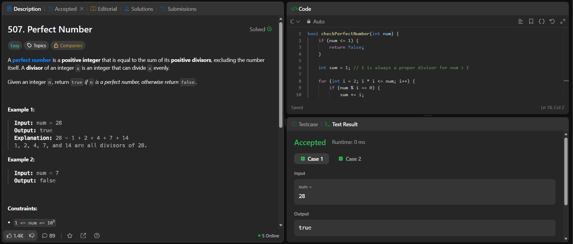
Source Code


